**MARK 1 PERCEPTRON**

The Mark 1 Perceptron, introduced in 1958 by Frank Rosenblatt, a psychologist at Cornell Aeronautical Laboratory, developed the perceptron as a simplified model of biological neural networks, designed to perform pattern recognition tasks. Its invention was intended to explore the possibilities of machine learning and how computers could simulate human-like learning processes.

The Mark 1 Perceptron was a hardware implementation of Rosenblatt’s theoretical model, utilizing electronic circuits, photoelectric sensors and adaptive weights to perform computations. This pioneering device was capable of recognizing simple patterns by adjusting the weights of its connections based on input data and feedback. It comprised three main components: an input layer, which received sensory data; an interconnection layer, where the computational learning occurred; and an output layer, which produced the system’s response. The perceptron’s ability to modify its weights through a supervised learning process demonstrated the principles of modern machine learning algorithms.

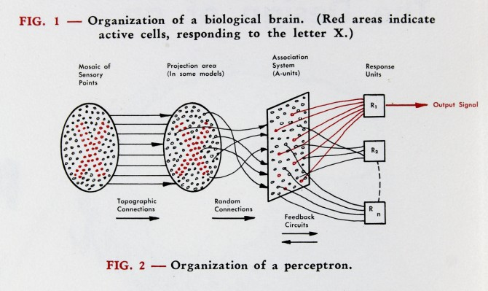

An image of the perceptron from Rosenblatt's “The Design of an Intelligent Automaton,” Summer 1958.

Rosenblatt’s perceptron was groundbreaking for its time and he presented it as a machine that could “learn” from examples without explicit programming. It was initially met with significant enthusiasm, with claims that it could potentially solve a wide range of cognitive tasks, from character recognition to decision-making. However, the perceptron had critical limitations. Marvin Minsky and Seymour Papert, in their 1969 book "Perceptrons," highlighted its inability to solve problems that were not linearly separable, such as the XOR problem. This criticism led to a temporary decline in interest in neural networks, a period often referred to as the "AI Winter."

Despite its limitations, the Mark 1 Perceptron laid the groundwork for subsequent advancements in neural networks and machine learning. Its principles have been extended and refined in modern artificial intelligence, influencing the development of multi-layered networks and backpropagation algorithms. The perceptron’s historical significance is underscored by its role in sparking early research and debate in the quest to build intelligent machines, making it a cornerstone in the evolution of AI technology.